1,Write a PL/SQL trigger named tri that is fired after inserting a record into the customer_details table. The trigger should display the message “A row is inserted” for each inserted row. Also write the SQL statement to test the trigger.
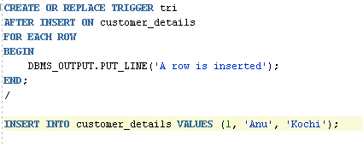
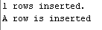
2. Write a PL/SQL trigger named trig that is executed after inserting a record into the emp_details table. The trigger should display the message “Salary is greater than 20000” only when the inserted salary is greater than 20000. Also write a statement to test the trigger.
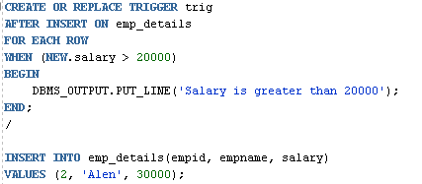
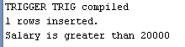
3. Create a table cust_count to store the number of rows in customer_details.
Write a trigger named trigg that:

Increments the count when a row is inserted

Decrements the count when a row is deleted

4.Create two tables deleted and updated to store deleted and updated records from the emp_details table.
Write a trigger named trigge that:
Stores deleted records into the deleted table
Stores updated records into the updated table
Also write SQL statements to test the trigger.

CREATE OR REPLACE TRIGGER trigge
BEFORE DELETE OR UPDATE ON emp_details
FOR EACH ROW
BEGIN
IF DELETING THEN
INSERT INTO deleted
VALUES (:OLD.empid, :OLD.empname, :OLD.salary);
ELSE
INSERT INTO updated
VALUES (:NEW.empid, :NEW.empname, :NEW.salary);
END IF;
END;
/
DELETE FROM emp_details WHERE empid = 2;
SELECT * FROM deleted;
